IS590PR Assignment6- Network Graphs & OO design

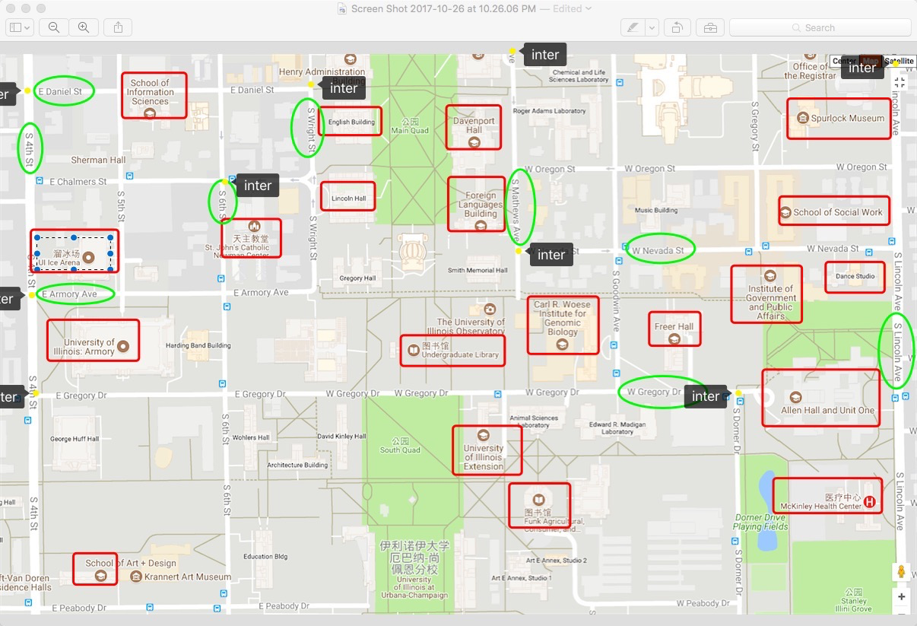

map for this assignment

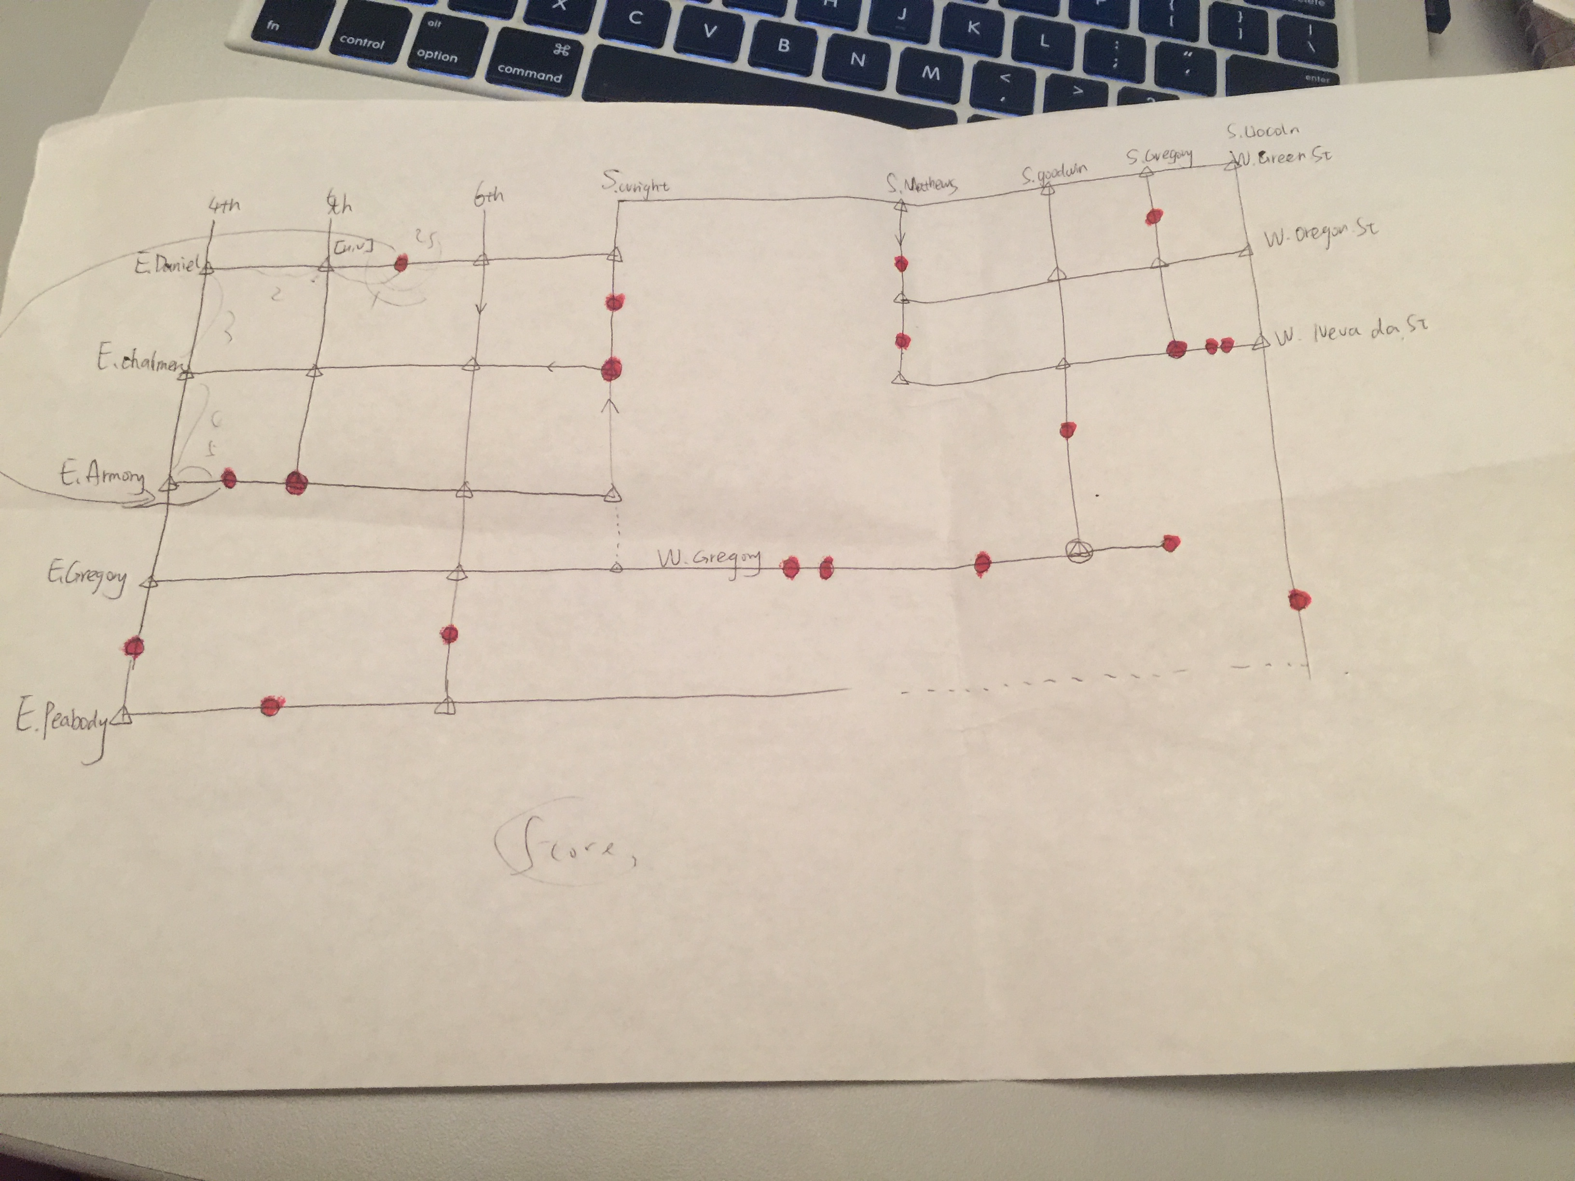

simplify into nodes and edges

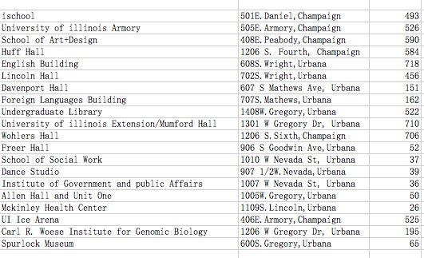

map code

this group work is completed by Lan Li, Jiajun Chen, Sixuan Shen, Akhila Khanapuri.

We have about four face-to-face group discussion.

1st stage: everyone talk about the cognition of the requirement and propose personal ideas of this project;

2nd stage: try to do some preparing work: like collecting the map code, and choose the area which is used to show the graph.(completed by leader of the group). Using these materials, the whole project will become more clearly.

3rd stage: teamers talk about the implementation of the project. And everyone shares themselves’ versions . originally, I try to write our own basic classes, including node, edge and graph. After that, using inheritance to construct school_map class. Jiajun Chen and Sixuan Shen mention that we can use the library networkx to construct the map, where the main function like add_edge; add_nodes; and find_shortest_path have already been existed.

4th stage: we decide to split the whole work into 4 parts: data and class construction (this part of work include designation of the data type); and find_shortest_path, input and output data.

As the whole map needs to be constructed manually, the data and class construction would be the most weighted work here, which are finished by Jiajun Chen and Sixuan Shen. They have finished great and effectively. The input and output part is finished by Akhila Khanapuri, who completes it quickly. And after all this stuff, I merge the code and write docstring into the code, and implement finding shortest path here, and output the path formation as the requirement.

-----------stage and work split

Lan Li

Here we four team partners want to share something from this assignment.

Lan Li

1. about the OOP theory, we construct one Navigation class to design our graph. And in our __init__ built function, we define attribute for this class, which is an instance of the networkx class DiGraph(). In this way, we overload the method for the DiGraph class.
2. Some kind of built in function in the DiGraph , like the shortest path function, the result should be transferred and then be used to output the formation . something meaningful I want to mention: like the number of nodes is one more than the street.
3. The big advantage of OOP design is that the user don’t need to know what happens into this whole model, like people only need to input the map code, however, at the inner function, the data structure of the building_node is defined by building name and the street_name; in this way, I write a map formation to relate the input and the parameter here, where a dictionary to store the building as the building_node name.
4. **meta is a really great thing for python, in this way, we can add any arguments into our dictionary.
5. The input and output should consider more exceptions here: like what if people input nonsense map code here. This is an update.